* Core Features:
* **Map centric platform**
  + Idea is to have a map in the background basically at all times even if it’s blurred out if not important
  + API’s / Helpful Research
    - ESRI
    - Mapbox
    - Mapjam
    - GoogleMaps
    - Story Maps
    - Triposo
* 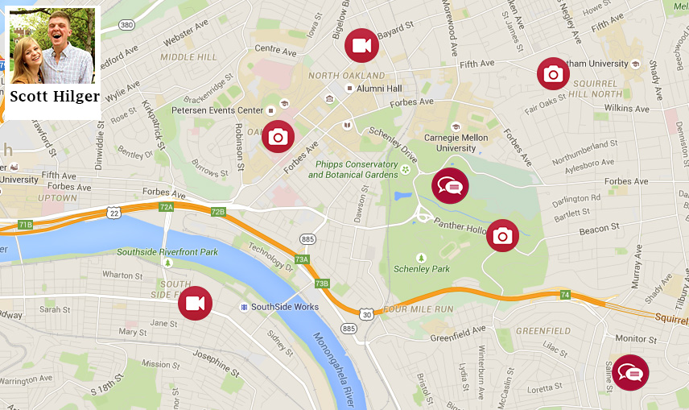
  + **Profiles:**
    - * School information
      * Confirm .edu account
      * Link to Facebook
      * Ability to enter interests
      * Follow people
      * Friends groups “Travel Buddies”
    - Profiles will be more map based showing media, reviews
    - Ability to post public, private, just so a specific group can see
* **“Fanny Pack”**
  + Sub-applications including translator, currency converter, quick weather, stocks
* **Search**
  + Search for things to do by interests, emotions, amount of money
  + Filter through friend’s with similar interests reviews first
  + Sharing places you search with friends
* **Chat**
  + Group chats
  + Pulls up list of people who have searched to do similar things so you can choose to be in a group chat with some of them
* 
 